**Co-relation between Metric 1, 2 and 4**

**Co-relation Between Metric 2 (Branch Coverage) and Metric 4 (Complexity Code Coverage):**

The Spearman Coefficients for all the projects (at class level) are written in the .xlsx file and the spearman Coefficient for all 5 projects at the project level is -0.5 which shows the string/medium, negative co-relation between Metric 2 and 4.

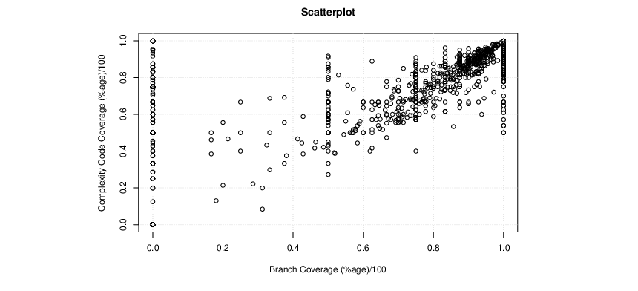

Fig. Scatter-Plot for Branch Coverage (%age)/100 Vs Complexity Code Coverage (%age)/100

**Co-relation Between Metric 1 (Statement Coverage) and Metric 4 (Complexity Code Coverage):**

The Spearman Coefficients for all the projects (at class level) are written in the .xlsx file and the spearman Coefficient for all 5 projects at the project level is -0.5 which shows the string/medium, negative co-relation between Metric 1 and 4.

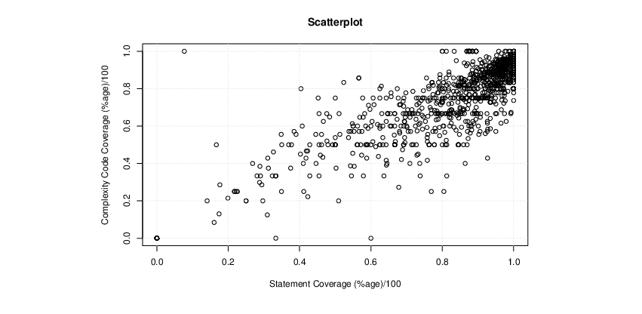

Fig. Scatter-Plot for Statement Coverage (%age)/100 Vs Complexity Code Coverage (%age)/100

Below are the class level Spearman Coefficient for all the Projects:

|  |  |  |
| --- | --- | --- |
| **Projects Name** | **Spearman Coefficient for Metric 1 and 4** | **Spearman Coefficient for Metric 2 and 4** |
| **Apache Commons Collections** | 0.920665321 | -0.026222491 |
| **Apache Commons Logging** | 0.203338807 | 0.48358 |
| **Apache Commons Configuration** | 0.818194 | -0.01075 |
| **Apache Commons File Upload** | 0.917260788 | 0.384615385 |
| **Apache Commons Math** | 0.807957484 | 0.058236547 |